Created by: Josh Kelly

NASA DEVELOP Geoscience Programming

3/6/2014

**Downloading the MODIS Reprojection Tool**

The MODIS Reprojection Tool (MRT) enables users to read data files in HDF-EOS format (MODIS level 2, 3, and 4 land data products) and specify science data sets as input to geographic transformations, resampling, and other processing techniques. Since ArcMap cannot read MODIS data in its original sinusoidal projection, MRT is used to project it to UTM.

1. Navigate to the following URL: <https://lpdaac.usgs.gov/tools/modis_reprojection_tool>
2. You are required to have an account with LP DAAC, so click *Can’t log in? Create an account* and follow the registration steps.
3. Once signed in, navigate back to the original URL shown above and click *Windows NT+ 32-bit* in the *Download* box.
4. Extract the contents within *MRT_download_Win.zip* folder to a known directory on your computer.
5. Open the folder where you extracted the files to and you should see four files – *mrt_install.bat*, *MRT_Win.zip*¸*reg_set.exe*, and *unzip.exe*.
6. Open the command prompt window (search the computer for *cmd*)
7. Change the directory to the folder where these files are located using the following command:

**cd C:\filepath\toMRT**

1. Run the MRT installation batch script by typing **mrt_install** in the next line. A series of instructions should have appeared in the window.
2. Press any key to continue
3. The prompt is going to ask you where you would like to install MRT. Choose the same file path that you used above and enter it into the prompt. If it says the directory does not exist, type **y** to create it.
4. After this is finished, it will ask you which version of Windows you’re running. Assuming that you are most likely running Windows XP or higher, type the number **1**.
5. Next, it will ask where your Java bin directory is located. In your desktop search window, search for *java.exe*. Open its properties and copy its location file path. Paste this file path into the command prompt.
6. Type the letter **y** in the next prompt
7. Hit enter at the next prompt to finish the installation.
8. Navigate to your MRT folder and you should see a number of folders and files that were created during the installation process. Make not of the *bin* folder as this is where the scripting tools are located.

**Using the MODIS Reprojection Tool in a Batch Process**

Multiple MODIS data files can be mosaicked and reprojected automatically using the MODIS Reprojection Tool in a batch process.

1. The first thing that needs to be done is to create the MRT Parameter file (.prm).
2. Open the *bin* folder located within the MRT directory and open *ModisTool.bat*. This will open the MRT Graphical User Interface.
3. Click *Open Input File* and navigate to the folder containing your HDF files and select one.
4. In the *Selected Bands* window, select the datasets that you would like to keep.
5. Specify the coordinates (in decimal degrees) of the UL and LR corners of the MODIS tiles (if you are merging multiple tiles together, then these coordinates must represent the UL and LR of the final merged product).
6. Create a new folder within the same directory as your HDF folder. This one will be used to store your output TIFF files.
7. Click *Specify Output File* and navigate to the empty TIFF folder you just created and give it a name.
8. Specify your *Output File Type* (usually GeoTIFF)
9. Specify *Resampling Type* (usually Nearest Neighbor)
10. Specify your *Output Projection Type*
11. Click *Edit Projection Parameters* and specify your UTM Zone window and Datum
12. Specify the data’s *Output Pixel Size*
13. Then save the parameter file (.prm) by clicking *Save Parameter File*
14. 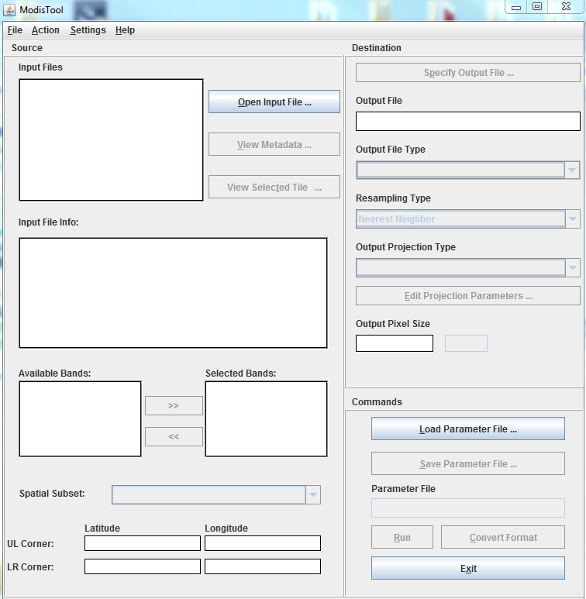Open this newly created parameter file in a text editor such as Notepad and make sure that all of the fields are filled in properly. The *UTM_Zone* field may show **0** so replace it with the desired numberif that happens.
15. Navigate to the JARBatch.bat file contained within the tutorial package and open it in Notepad.
16. To the right of **–d**, change the file path to the location of your HDF folder.
17. To the right of **–p**, change the file path to the location of the Parameter file.
18. Save the file to the **bin** folder found within MRT’s directory
19. Open the command prompt window and change your directory to MRT’s **bin** folder.
20. Type **JARBatch_Tutorial.bat** and press enter
21. The mosaicking and reprojection processes will now be performed and status updates will be provided in the command prompt window.
22. The TIFFs have been placed in a folder called **prm** located within your HDF folder. You can choose to leave them in there or place them in the previously created TIFF folder.